Apache POI

[Draw your reader in with an engaging abstract. It is typically a short summary of the document. When you’re ready to add your content, just click here and start typing.]
[Document title]
[Document subtitle]

KNIGHT’S BLVD
Retail Management System
Project Overview
Knight’s Blvd is a Python-based retail management system developed to simulate and manage the core operations of a small retail business.
The system provides functionality for managing products, customers, inventory, orders, and sales while storing business data in an SQLite database.
The project was built from the ground up to demonstrate practical software development skills, including object-oriented programming, database management, input validation, debugging, error handling, and software testing.

───

Problem
Small retail businesses need a reliable way to keep track of products, customers, stock, and sales.
Knight’s Blvd was created as a practical software solution that brings these operations together into one system rather than managing them separately.

───

Objectives
The main objectives of the project were to:
- Build a functional retail management system using Python.
- Create reusable classes for different parts of the business.
- Store and retrieve information using SQLite.
- Manage product inventory and stock levels.
- Register and manage customers.
- Process customer orders.
- Record completed sales.
- Generate purchase receipts.
- Validate user input and handle invalid information.
- Test individual features and the complete application workflow.
Use Git/GitHub to manage the project's development history.

───

Core Features
Product Management
- Add products to the system.

- Store product information such as name, colour, price, and stock.
- View available products.
- Search for products by name.
- Search for products by colour.
Inventory Management
- Track available stock.
- Reduce stock when products are purchased.
- Prevent invalid stock operations.
Customer Management
- Register customers.
- Store customer information.
- Associate customers with orders and sales

Order Management
- Create customer orders.
- Select products and quantities.

- Calculate order totals.
- Update inventory after a successful purchase.
Sales & Receipts
- Record completed sales.
- Generate receipts containing relevant transaction information.
- Display customer, product, quantity, price, total, order ID, status, and date.
Database
The application uses SQLite to persist information instead of relying only on temporary program data.

───

Technologies

───

Project Structure
Technology | Purpose
Python | Application development
SQLite | Data storage
Object-Oriented Programming | System architecture
Git | Version control
GitHub | Repository and project history
VS Code | Development environment

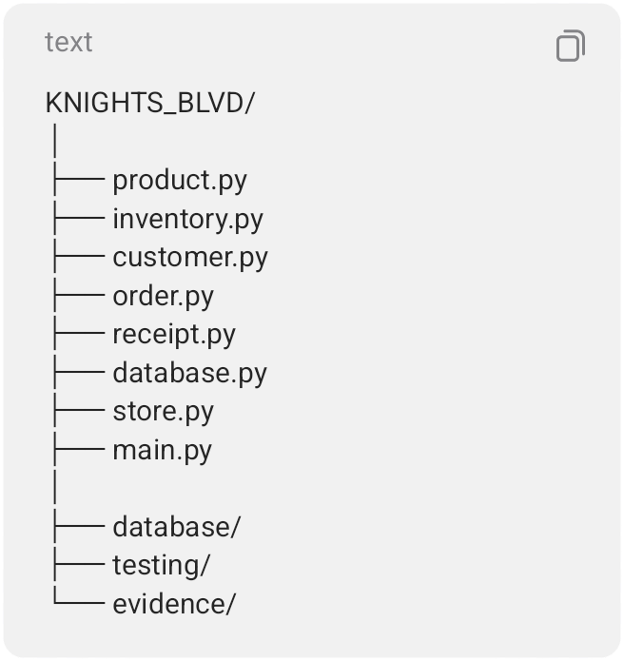

───

Testing
Testing was performed throughout development

rather than only after the system was completed.
Examples of tested scenarios include:
- Valid product registration
- Product searching
- Customer registration
- Order processing
- Stock reduction
- Receipt generation
- Invalid user input
- Invalid quantities
- Duplicate customer information
- Database errors
- End-to-end purchasing workflows
Testing evidence is documented separately in the project's Testing and Evidence folders.

───

Example Transaction

A successful transaction can produce a receipt containing information such as:
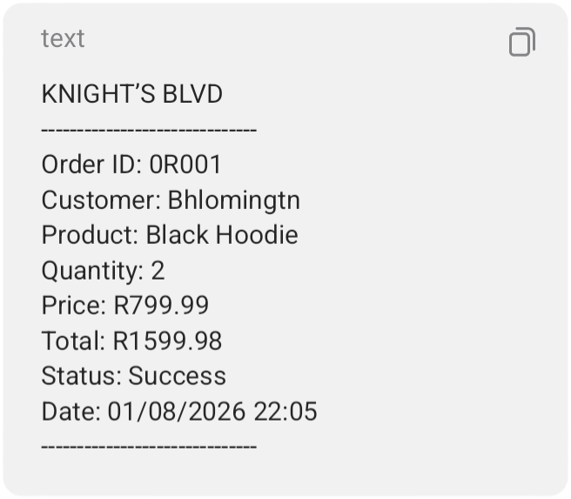

───

Skills Demonstrated
This project demonstrates practical experience

with:
- Python programming
- Object-oriented programming
- Classes and methods
- Functions
- Lists and data structures
- Conditional logic
- Loops
- Exception handling
- Input validation
- SQLite databases
- CRUD-style operations
- Inventory logic
- Debugging
- Software testing
- Test documentation
- Git/GitHub
- Building a multi-file application

───

Development Approach
Knight’s Blvd was developed incrementally.
Individual components were created and tested before being integrated into the larger system. Errors encountered during development were investigated, corrected, and retested.
This approach allowed the project to evolve from individual Python components into a connected retail management application.

───

Future Improvements
Potential future versions could include:
- Graphical user interface
- Login and user permissions
- Advanced sales reports
- Low-stock notifications

- Multiple product categories
- Product editing and deletion
- Customer purchase history
- Automated backups
- Barcode support
- Web or mobile interface
- Cloud database integration
- Automated testing
These features represent future development and are not claimed as part of the current version.

───

Project Status
Current Version: Version 1
Status: Functional prototype / portfolio project
Primary Language: Python
Database: SQLite

───

Purpose as a Portfolio Project
Knight’s Blvd demonstrates the ability to take a real-world business problem, break it into smaller software components, develop those components, connect them through a database, test the resulting system, and document the development process.
The project is intended to demonstrate practical software development ability rather than simply isolated programming exercises.
